Internship /placement organized : Finecons pvt Ltd chennai
Communication with the Alumni
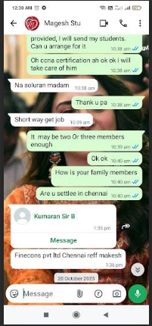
Communication with the owner of the company
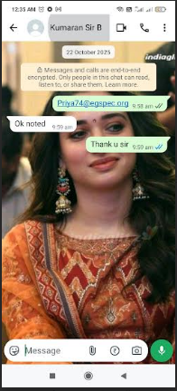

Gave information to manikandan sir for further processing
